- Introduction
This report documents the Vulnerability Assessment conducted as part of Task 1 under the Cyber Security Internship Program by Future Interns. The objective of this task is to identify common web security vulnerabilities in a live website, classify risk levels, and provide clear remediation steps.

- Scope of Assessment
• Passive vulnerability assessment only
• No exploitation or active attacks performed
• Black-box testing approach

- Tools Used
• Nmap
• OWASP ZAP (Passive Scan)
• Browser Developer Tools
• Canva
• GitHub
4. Methodology
1. Target identification
2. Passive scanning and reconnaissance
3. Manual inspection using browser tools
4. Risk classification
5. Documentation and reporting
5. Key Findings
Missing Security Headers (Medium Risk):
Some HTTP security headers were not implemented, increasing the risk of client-side attacks.
Information Disclosure (Low Risk): Server and framework information was visible in response headers. Insecure Cookies (Medium Risk): Cookies were missing Secure and HttpOnly flags.
Vulnerability | Risk
Missing Security Headers | Medium
Information Disclosure | Low
Insecure Cookie | Medium

6. Business Impact
If these vulnerabilities are not addressed, they may lead to reduced customer trust, increased exposure to cyber attacks, and potential compliance issues.

7. Recommendations
• Implement recommended HTTP security headers
• Secure cookies using Secure and HttpOnly flags
• Perform regular vulnerability assessments

8. Conclusion
This assessment highlights the importance of proactive web security testing. Addressing the identified issues will significantly improve the overall security posture of the website.

Proof of concept:


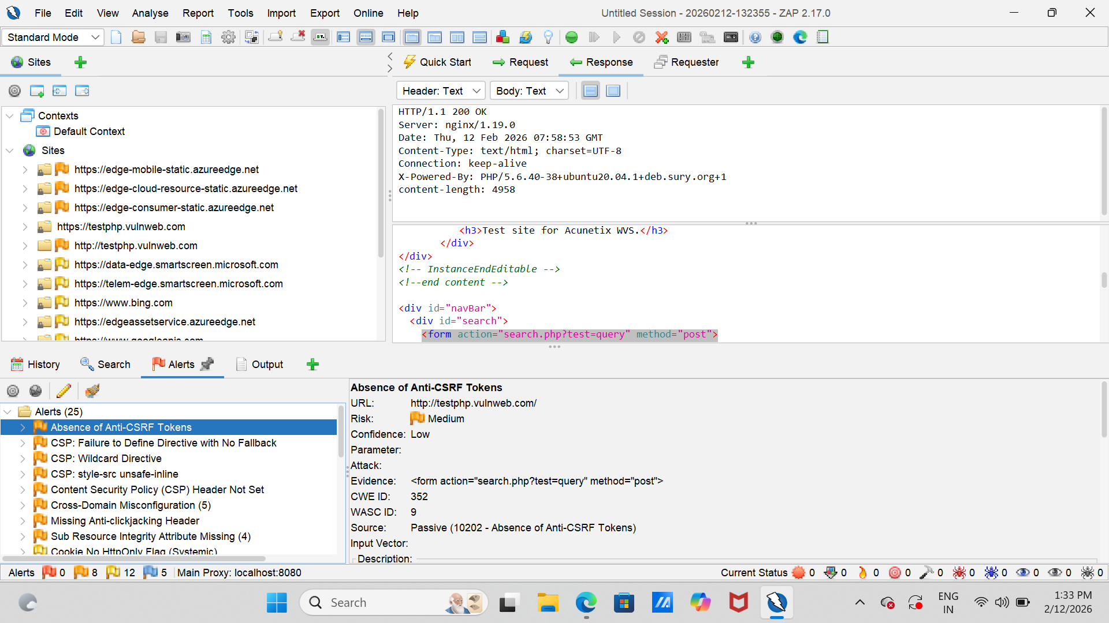

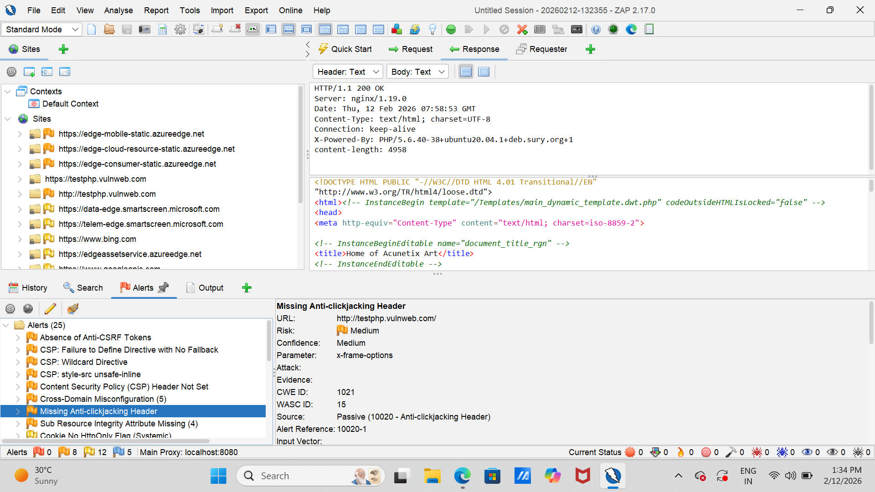

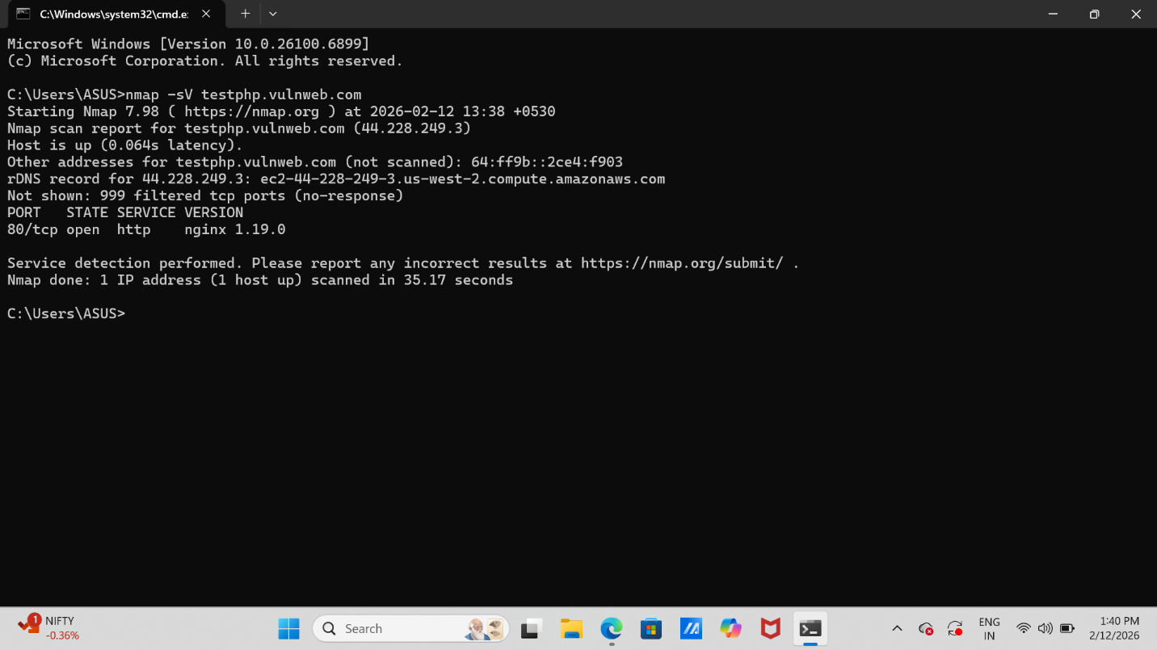

Prepared by: priyanshi suthar
Organization: Future Interns
Task: Cyber Security – Task 1

